Hello (First Name),
I am writing to you today to see if you would like to join me in being part of the GrowFL Florida Companies to Watch Awards Gala (FLCTW) and consider a sponsorship. Click on the video below to learn more about this great program, which honors the top growth companies in the state of Florida. It’s the most anticipated awards program of the year.
The upcoming event—held in partnership with Nperspective CFO & Strategic Services and the Edward Lowe Foundation is scheduled for February 17, 2022, in Orlando.
FLCTW sponsors enjoy a robust benefits package that should enhance your own marketing and business development strategies. Highlights of the array of benefits include:
- Your on-stage presence and recognition during the awards ceremony, and the opportunity for you to present an honoree to the audience;
- Access to the events VIP Reception for those being honored during the ceremony;
- Recognition in FLCTW online program and GrowFL Website;
- Complimentary admissions to the event;
- Contact list of all honorees (post-event).
Click here to view the GrowFL Florida Companies to Watch Sponsorship Guide and watch the video below.
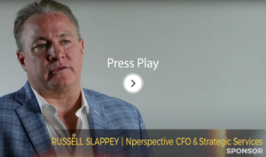
https://youtu.be/R8KNB-zU4L4

After you have had the opportunity to review the videos and document, please let us know if you would like to learn more. To facilitate the process, I have copied Mike Bobroff, GrowFL’s Investor Relations Consultant, who is our sponsorship expert. He can be reached at mbobroff@growfl.com and 407.765.1919.
In advance, thank you for your consideration of becoming an FLCTW sponsor.
Warm regards,
{Name}

